# Access Policy / Secure Web Gateway

Create global blacklist category:

1. Navigate to Access Policy > Secure Web Gateway > URL Categories and then click the **Create…** button.
2. In the **Name** field, type a name for the blacklist category (e.g. Global-Blacklist).
3. You must add at least one URL to the **Associated URLs** list in order for the category to save. This URL is simply a placeholder and will be replaced by the blacklist download script.
4. Click the **Finished** button.

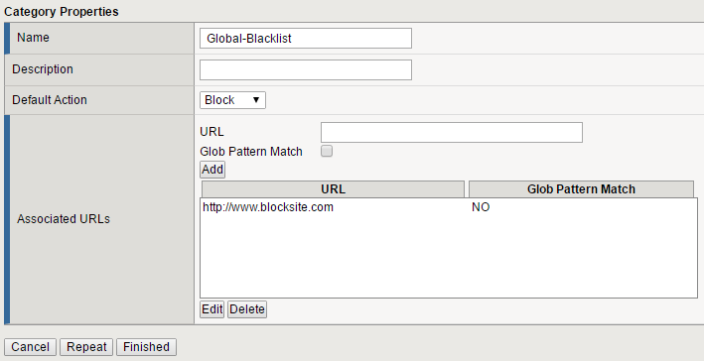

Upload Python script and configure iCall to facilitate scheduled global blacklist updates:

1. Connect to the BIG-IP using an SFTP client.
2. Upload **update.py** to **/var/tmp/category_update/** (create directory if it does not exist).
3. Connect to the BIG-IP command line and ensure you are in Traffic Management Shell (tmsh from the bash prompt).
4. Enter the following command to create a new iCall script named **global-block-download**:  
   create /sys icall script global-block-download
5. In the text editor that appears, type: :set paste
6. Press the **i** key (the editor is now in INSERT (paste) mode) and then paste the contents of iCall.txt in the **definition** section (between the curly braces).
7. Close the editor by hitting the **Esc** key, and then typing: :wq
8. Press the **y** key to save changes.
9. Enter the following command to schedule periodic execution of the iCall script:  
   create /sys icall handler periodic global-block-download interval 900 script global-block-download first-occurrence now
10. Save the configuration changes with the following command:  
    save /sys config

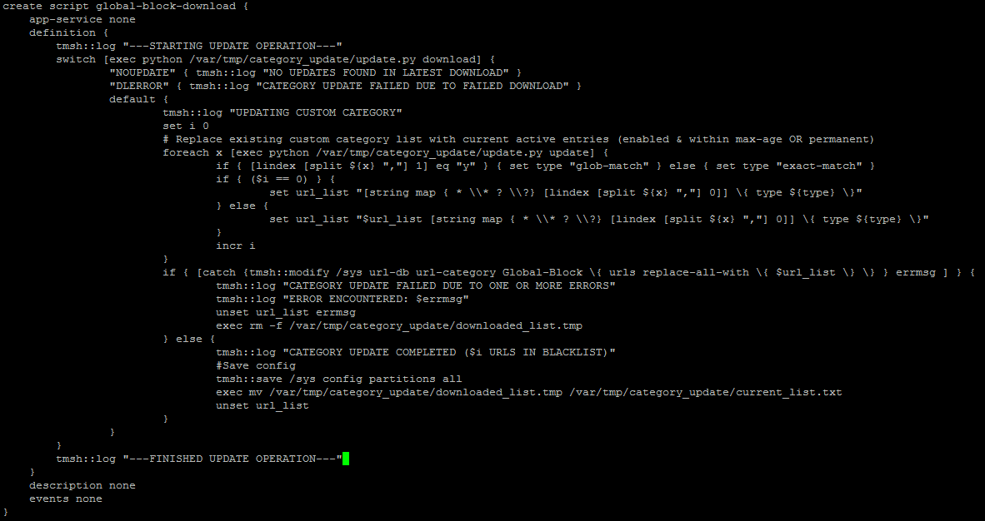

Uploading hosted content:

1. Navigate to Access Policy > Hosted Content > Manage Files and then click the **Upload** button.
2. Click the **Browse** button next to **Select File** and choose the blocking page media file.
3. Click the **OK** button.
4. Select the file that was just uploaded and click the **Edit** button.
5. Ensure the **Mime Type** is set correctly according to the following table:

|  |  |
| --- | --- |
| File Name | Mime Type |
| block.css | Cascading Style Sheets (CSS) |
| sig-blk-eng.svg | Scalable Vector Graphics (SVG) |
| wordmark.gif | Graphics Interchange Format |

1. Repeat steps 1 – 3 until all media files have been uploaded.